**Project Title**:

College Management Application

**Project By: Yashaswini V Patel**

**(yashuvpatel23@gmail.com)**

**(6366399955)**

**Day 1** :

**Topic:** Create Your Salesforce Developer Org To Get Started

**Activities:** Creating a developer org in salesforce.

Detailed Description:

1)Creating an Account Go to <https://developer.salesforce.com/>

* Click on sign up.
* On the sign up form,
* Fill in the following details : First name & Last name,Email
* Role : Developer
* Company : College Name
* County : India
* Postal Code : pin code
* Username : should be a combination of your name and company This need not be an actual email id, you can give anything in the format :username@organization.com
* After Entering All the information an email will be sent to verify the account.

2)Account Activation:

* Click on verify account.
* Enter the password.
* Select security question of your wish and fill in the answer.
* Click on change password.

3)Login To Your Salesforce Account:

* Go to [salesforce.com](https://www.salesforce.com/in/?ir=1) and click on login.
* Enter the username and password that was just created.
* After login this is the home page is visible.

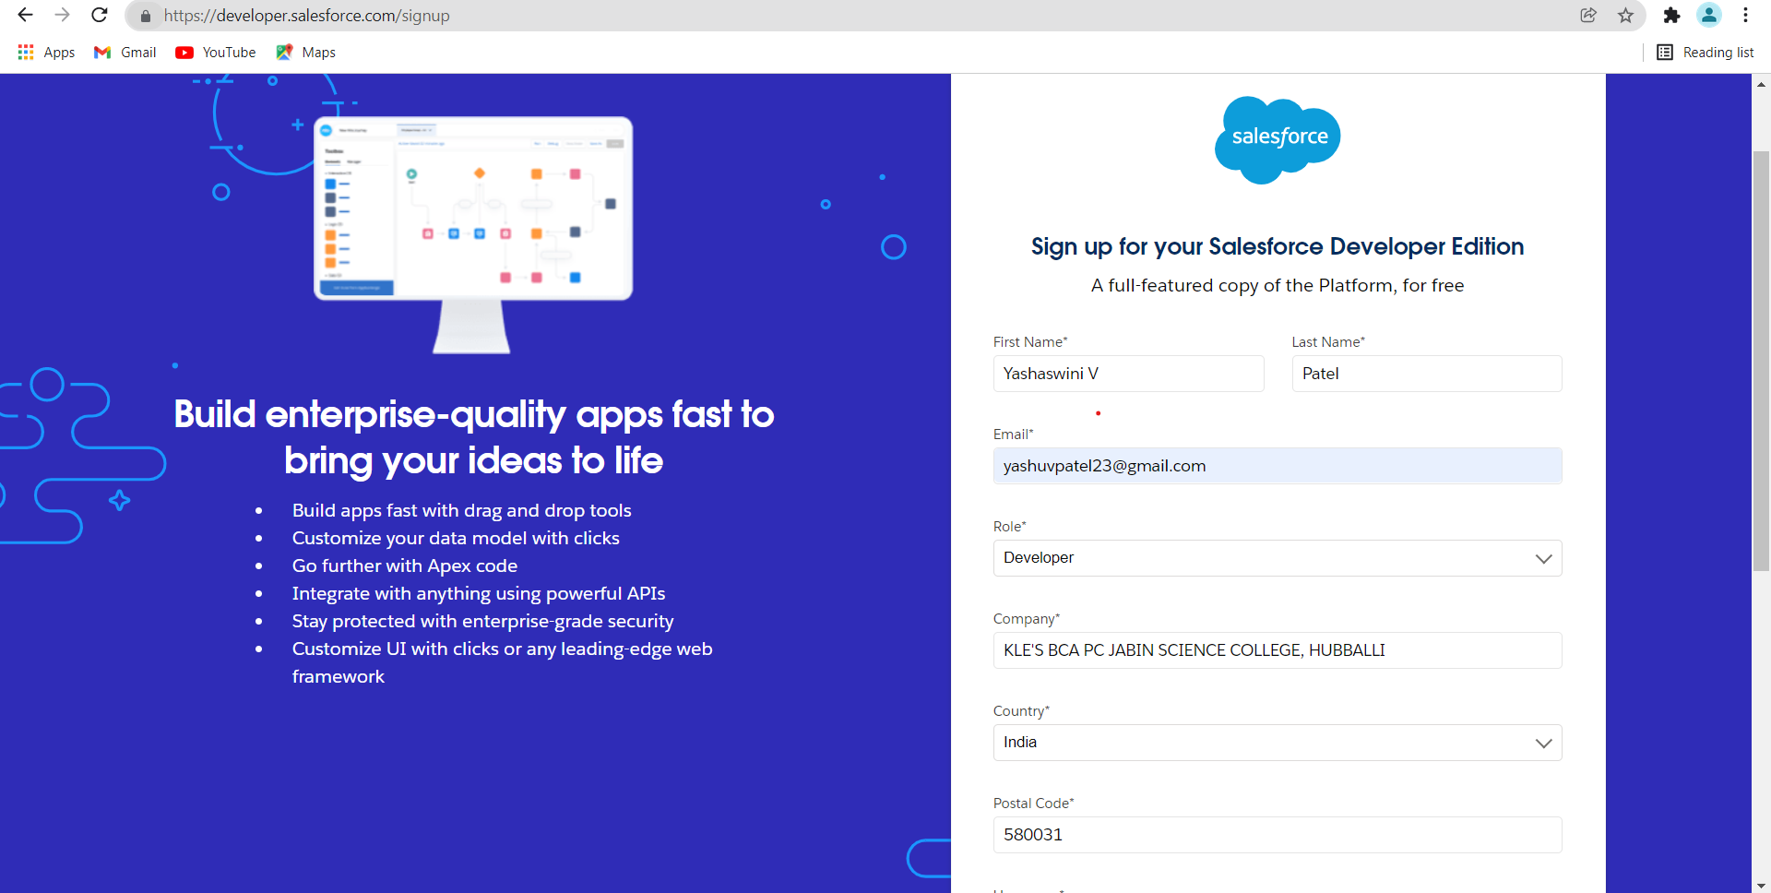

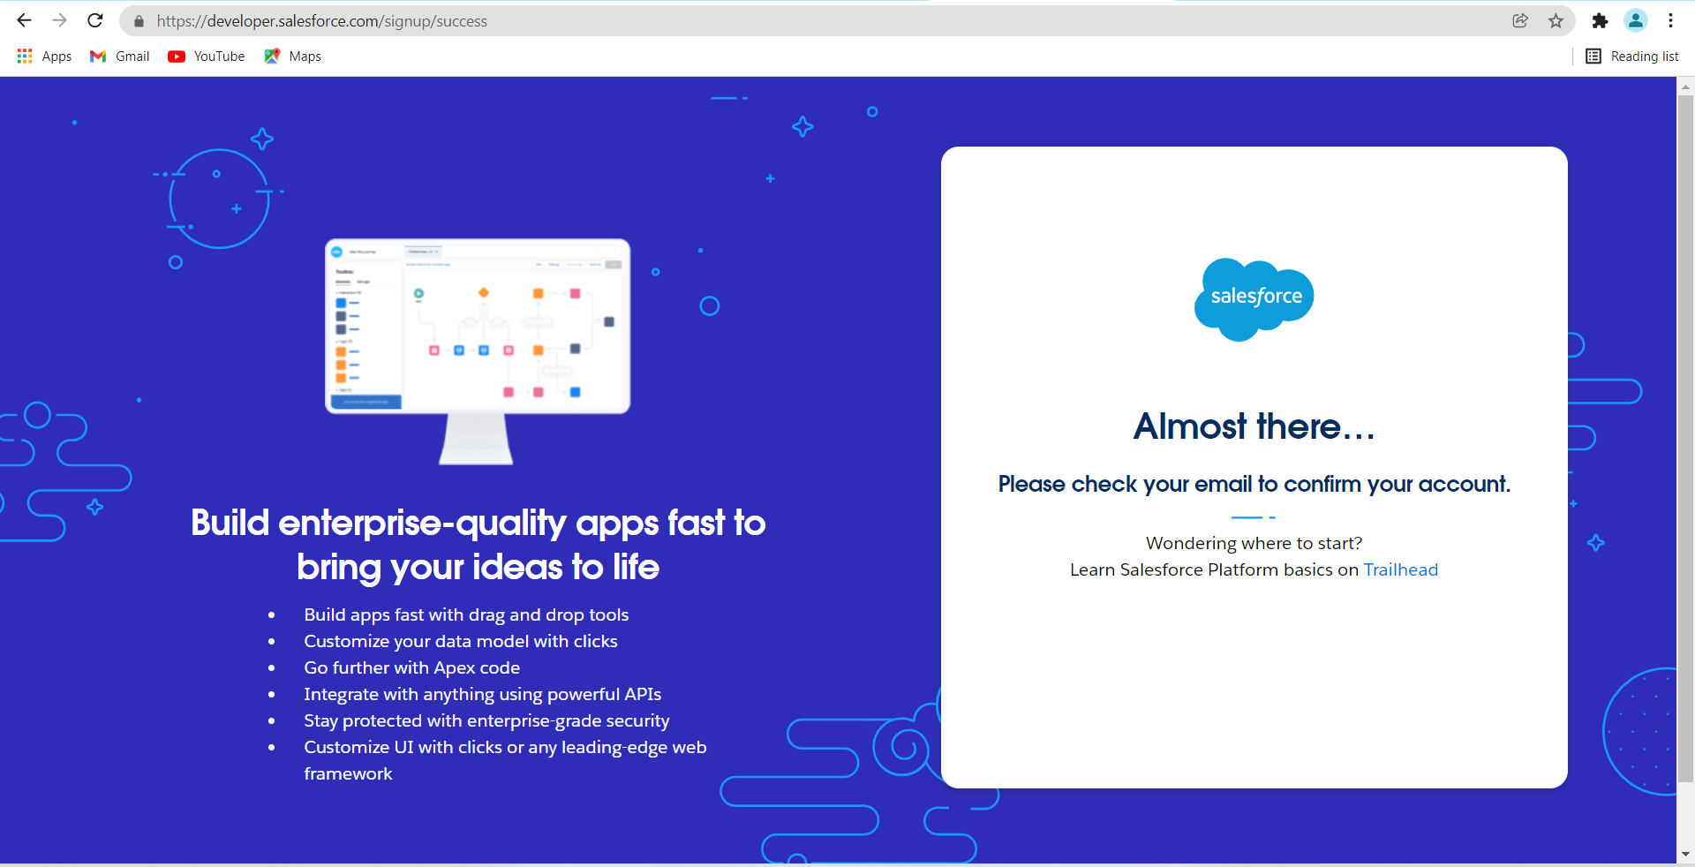

2) Account Activation

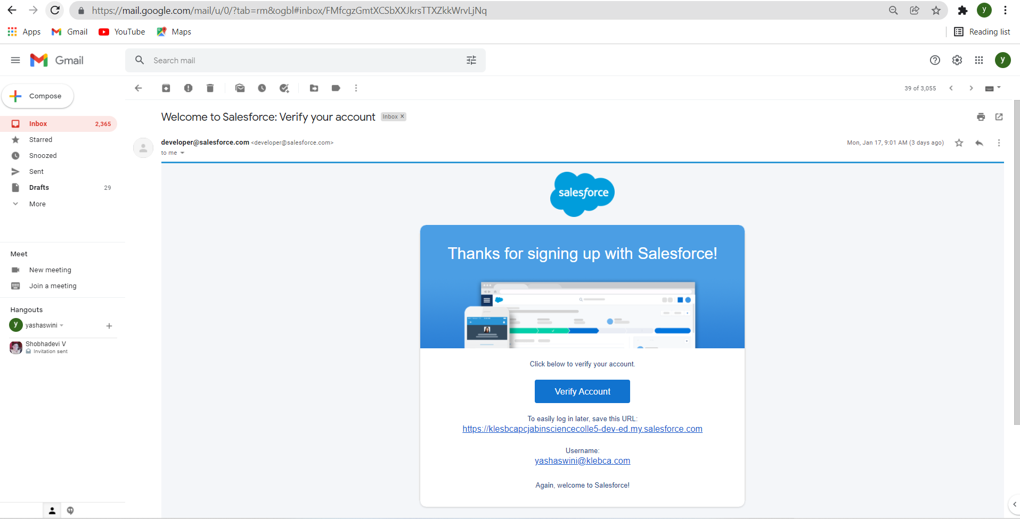

3)Login into your Salesforce account

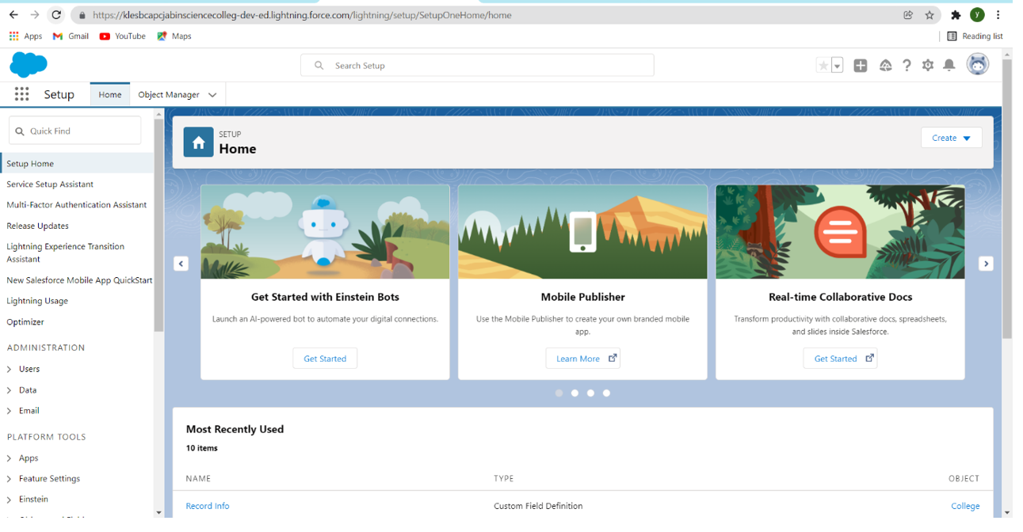

**DAY 2:**

Custom Object and Filed Creation

Activities: Create the Custom Objects and Fields

Detailed Description: Creating the following Custom Objects For the Application.

1. College

2. Application Form.

3. Students.

4. Subjects.

1) Create the Custom Object :- College

1. Click on the object manager > New>Custom Object

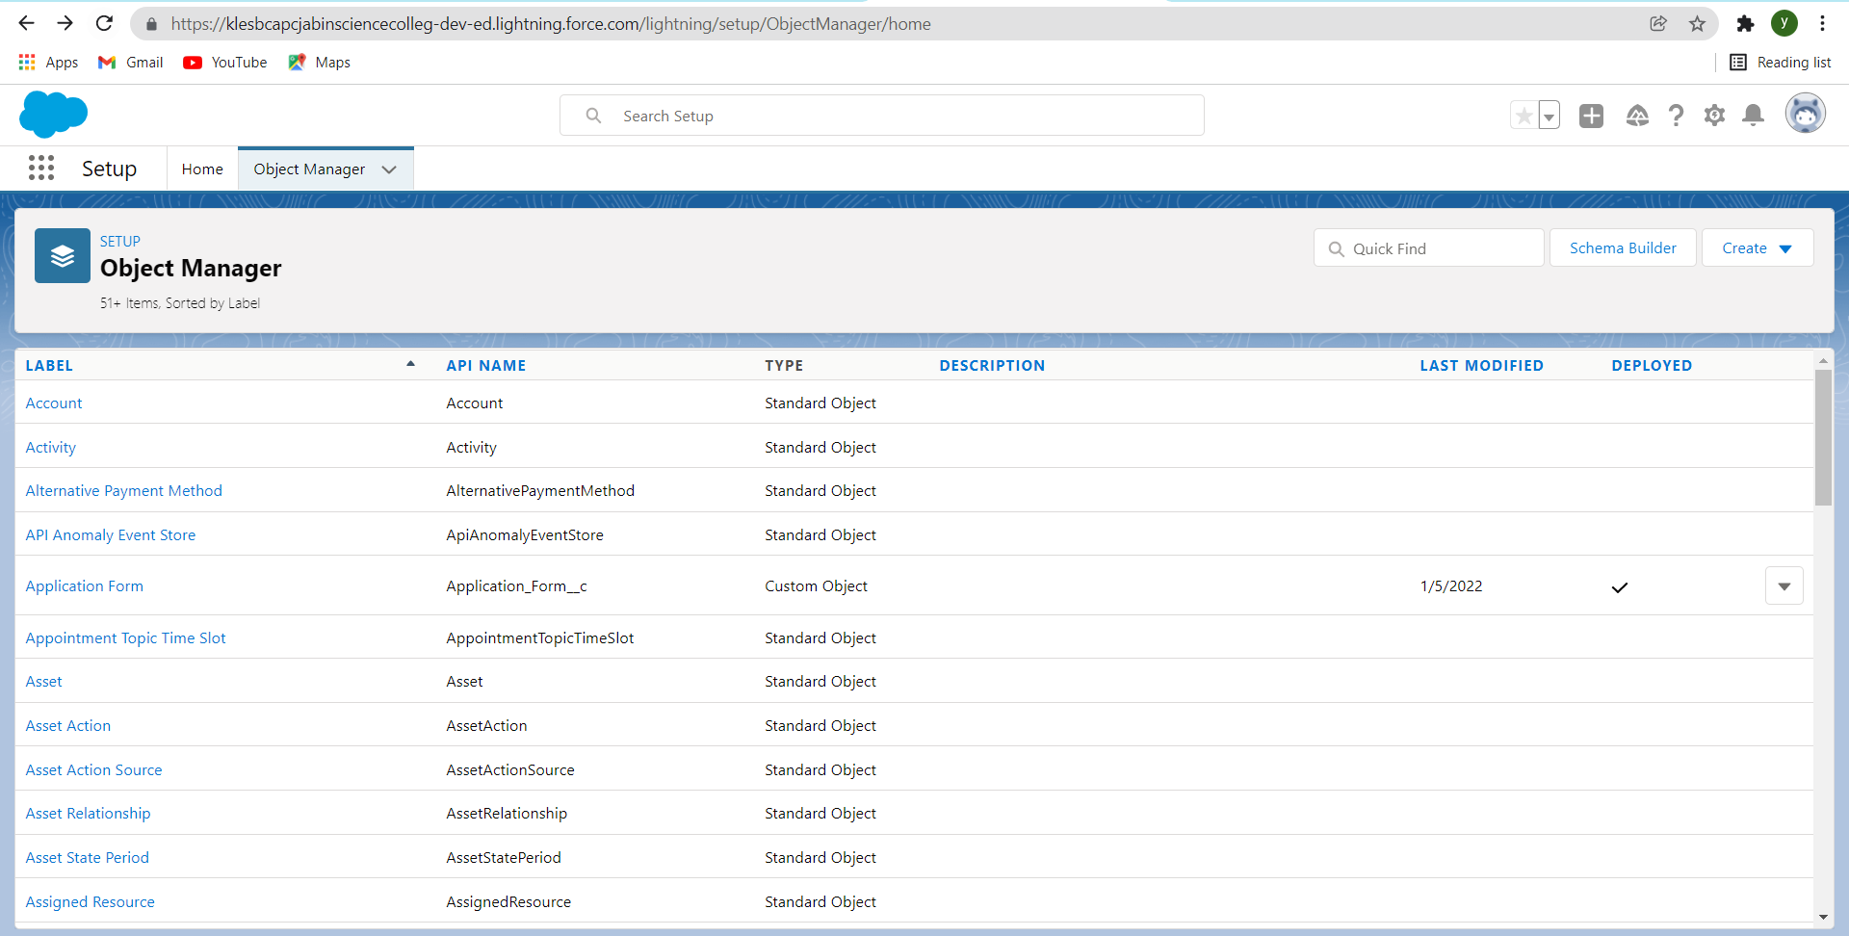

2)Enter all the required values as shown below

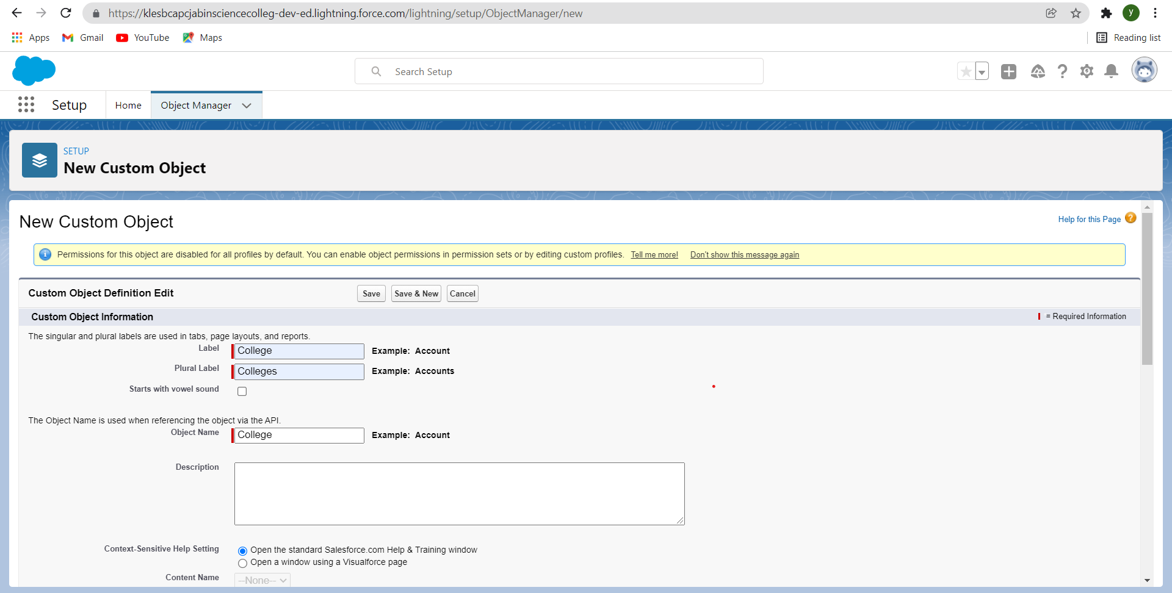

3)Click on Save > select all the tabs which this object has to be visible > Save.

4)After creating the College object looks something like

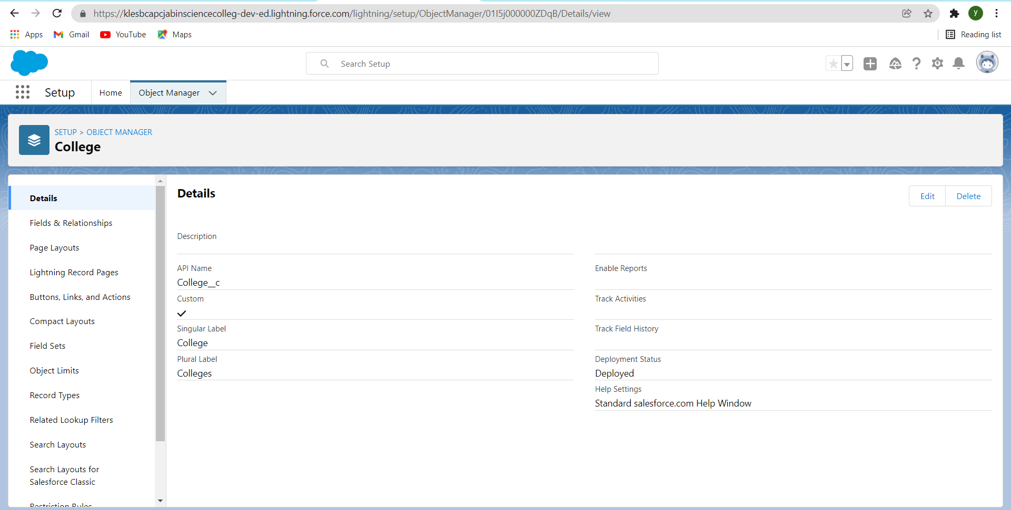

4) Similarly create the Application Form,Students,Subjects Objects.

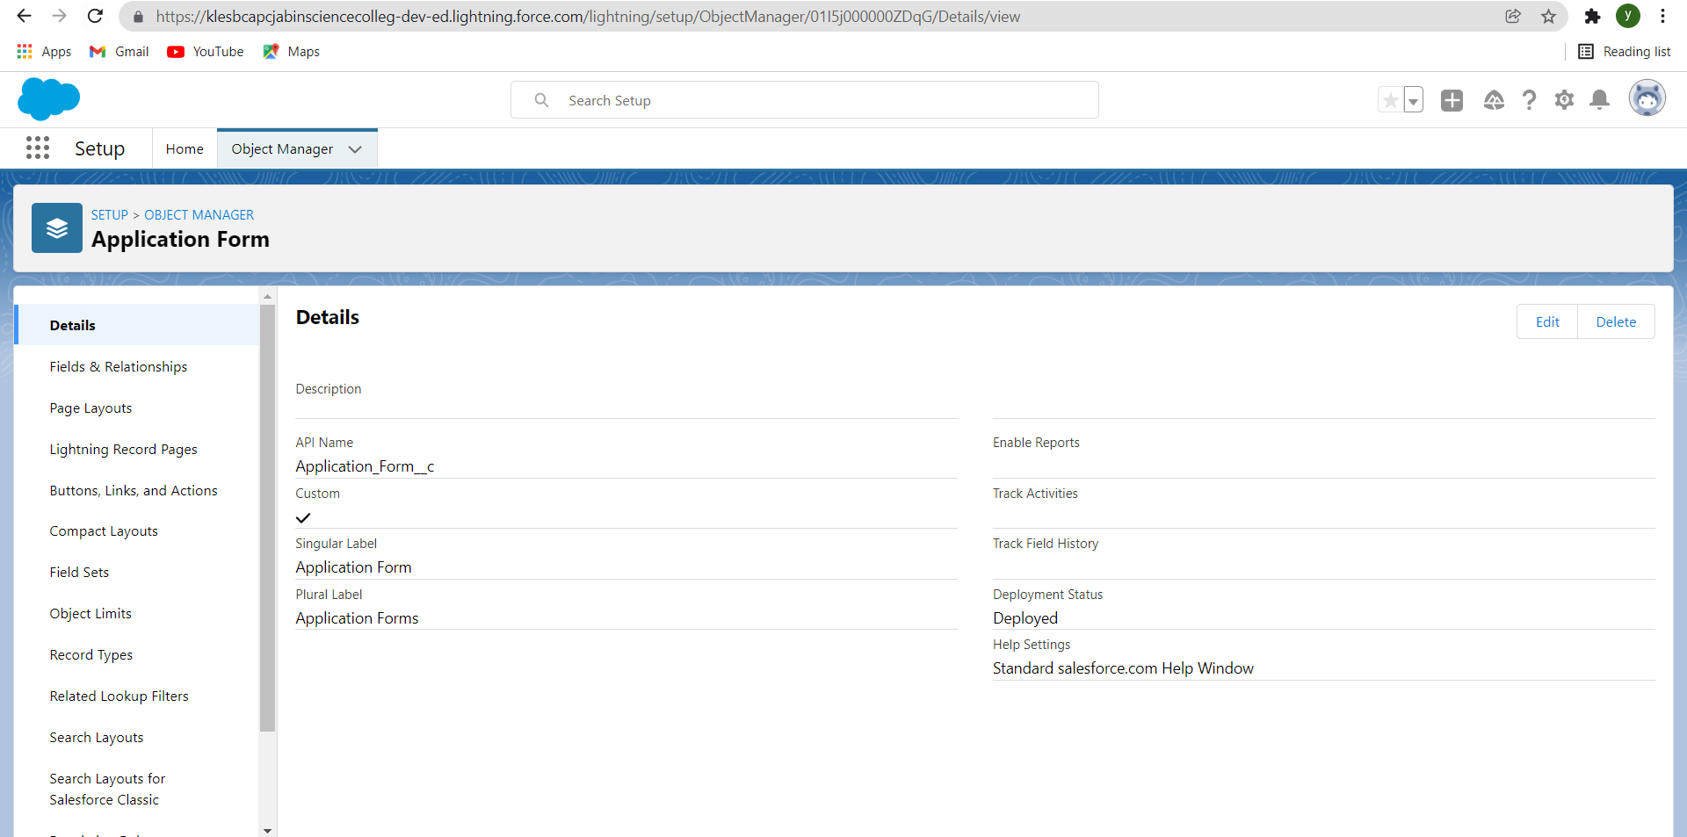

Create the following fields on the college object.

|  |  |  |  |
| --- | --- | --- | --- |
| Field Name | Data Type | Required | Values |
| Record Info | Text |  |  |
| College Fees | Currency(7,2) | Yes |  |
| Hostel Fees | Currency(6,2) | Yes |  |
| College Name | Picklist(Refer Business Logic In Milestones) | Yes |  |
| Email | Picklist |  | blr@mit.co.in  hyd@mit.co.in  mum@mit.co.in  maa@mit.co.in  ccu@mit.co.in  del@mit.co.in |
| Capacity Of Students | Picklist |  | 500-1000, 1000-2500, 2500-6000, 6000-10000 |

* To create custom fields
* Click on fields and relationships>
* Click on New >Select the required datatype

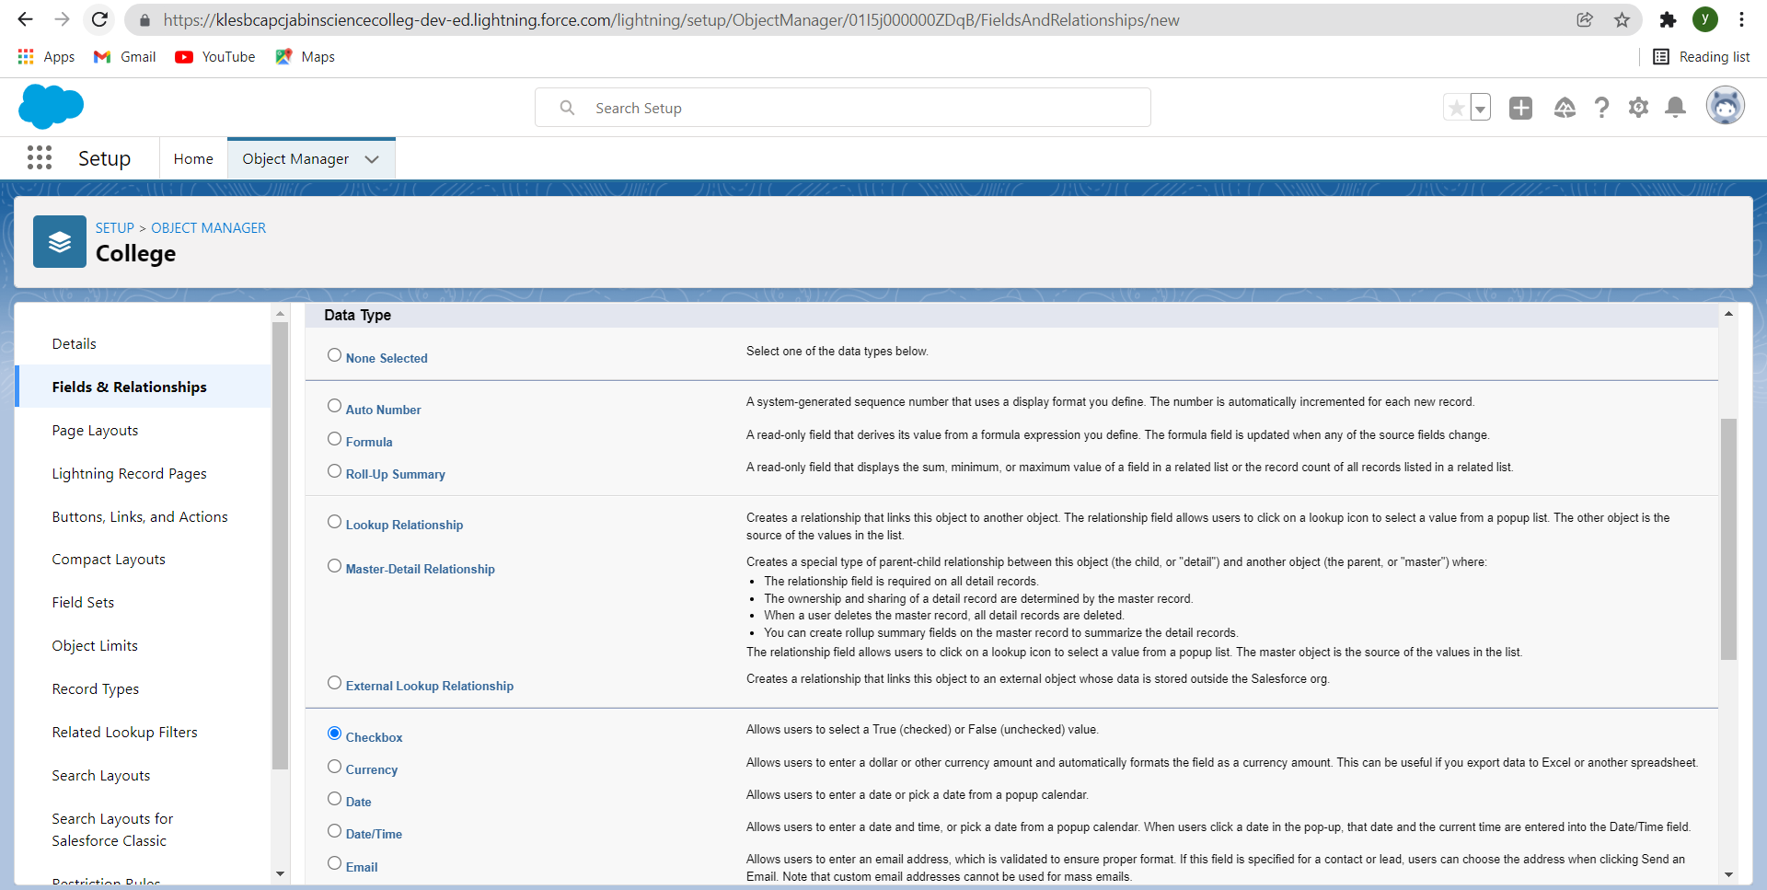

* Enter all the necessary information and check the checkbox of required if the field is mentioned as required >

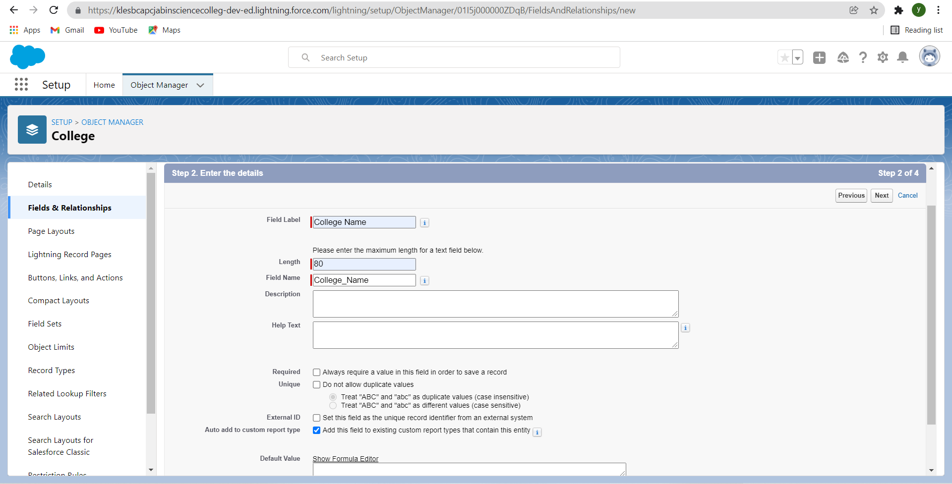

* Next>Next>Save and new
* Repeat this for all other fields of Application form , Students , Subjects Objects as well.

After creating fields,the fileds and relationships looks something like this

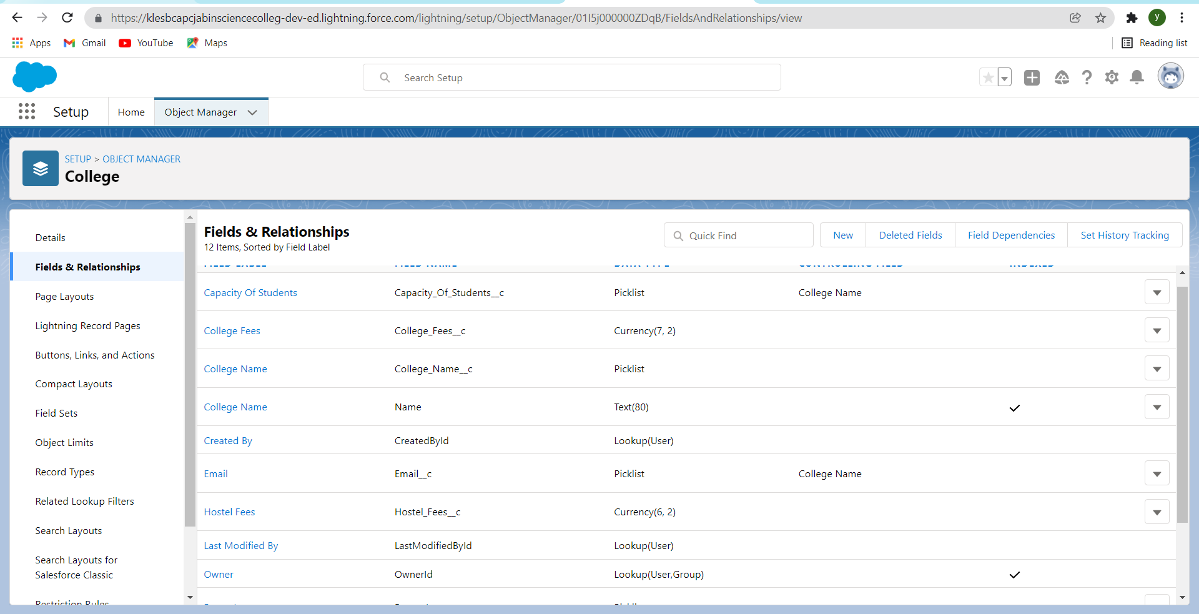

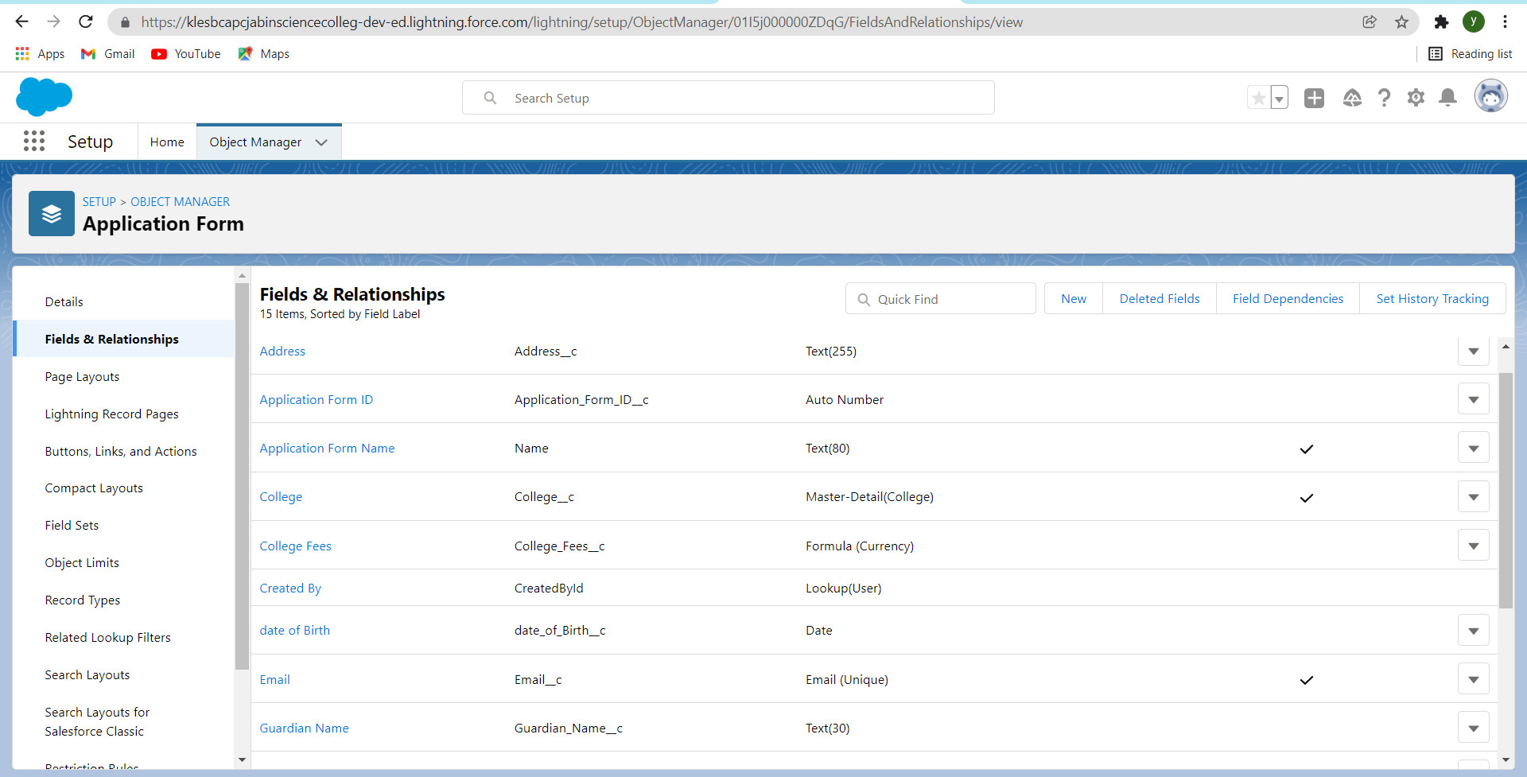

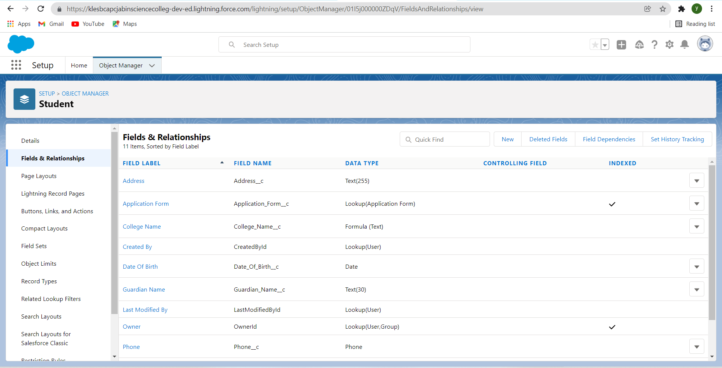

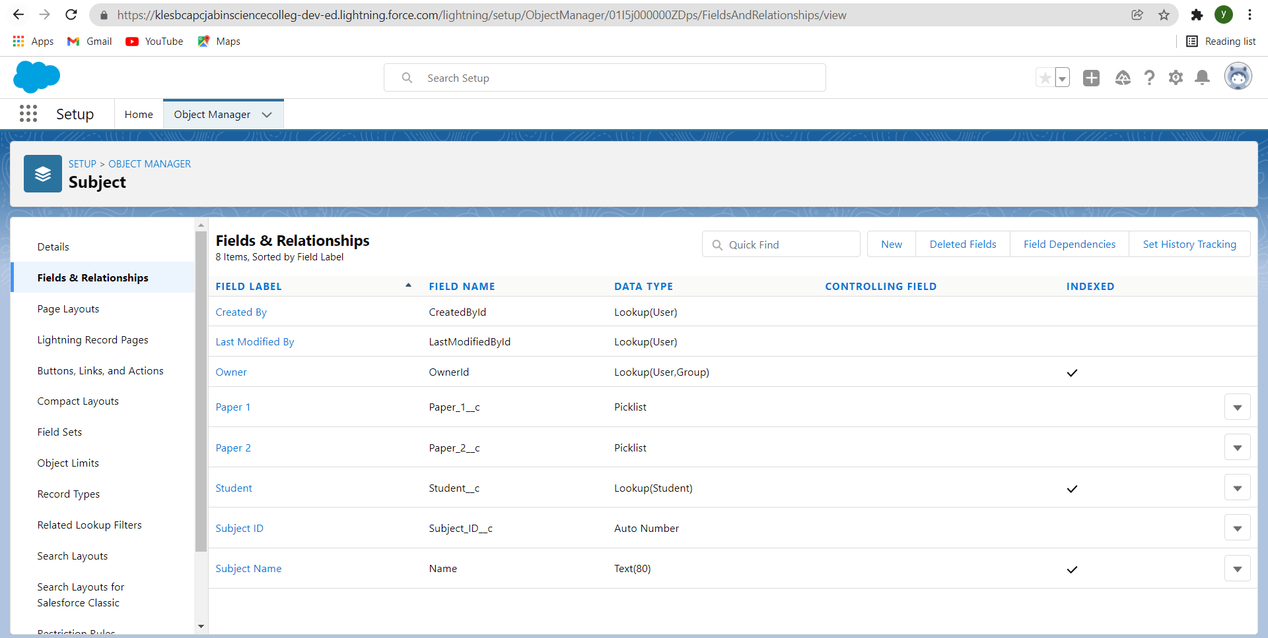

**Day 3 :**

Creating Global Picklist Value Sets

Activities: 1)College

2)Paper 1

3)Paper 2

Detailed Description:

Create the following global picklist value sets for the application.

1)College

|  |  |
| --- | --- |
| Picklist Value Name | Values |
| Colllege | MIT-HYD  MIT-BLR  MIT-MUM  MIT-MAA  MIT-DEL  MIT-CCU |

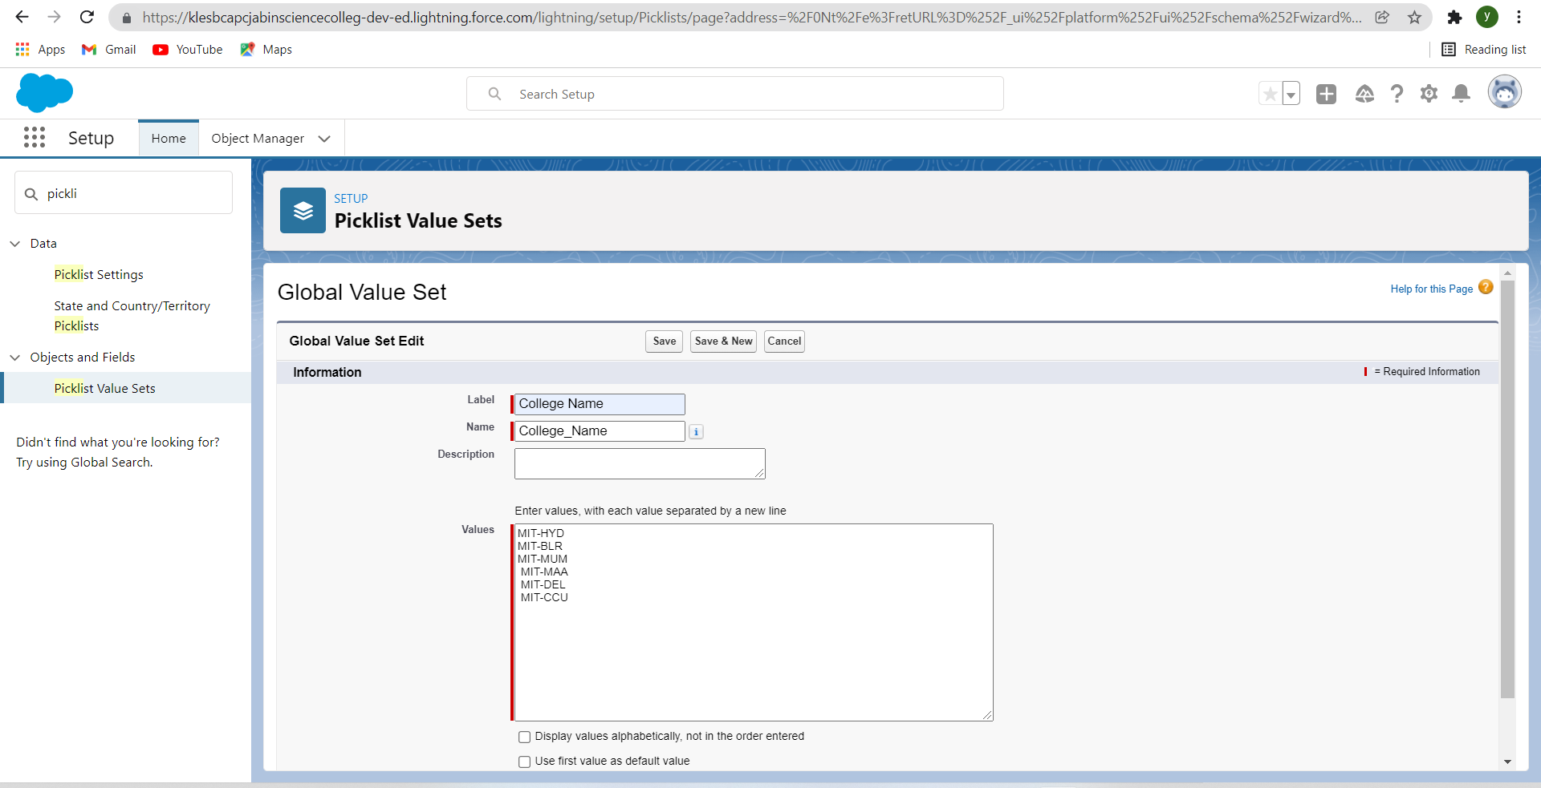

2)Paper1

|  |  |
| --- | --- |
| Picklist Value Name | Values |
| Paper 1 | APEX  JAVA  C  C++ |

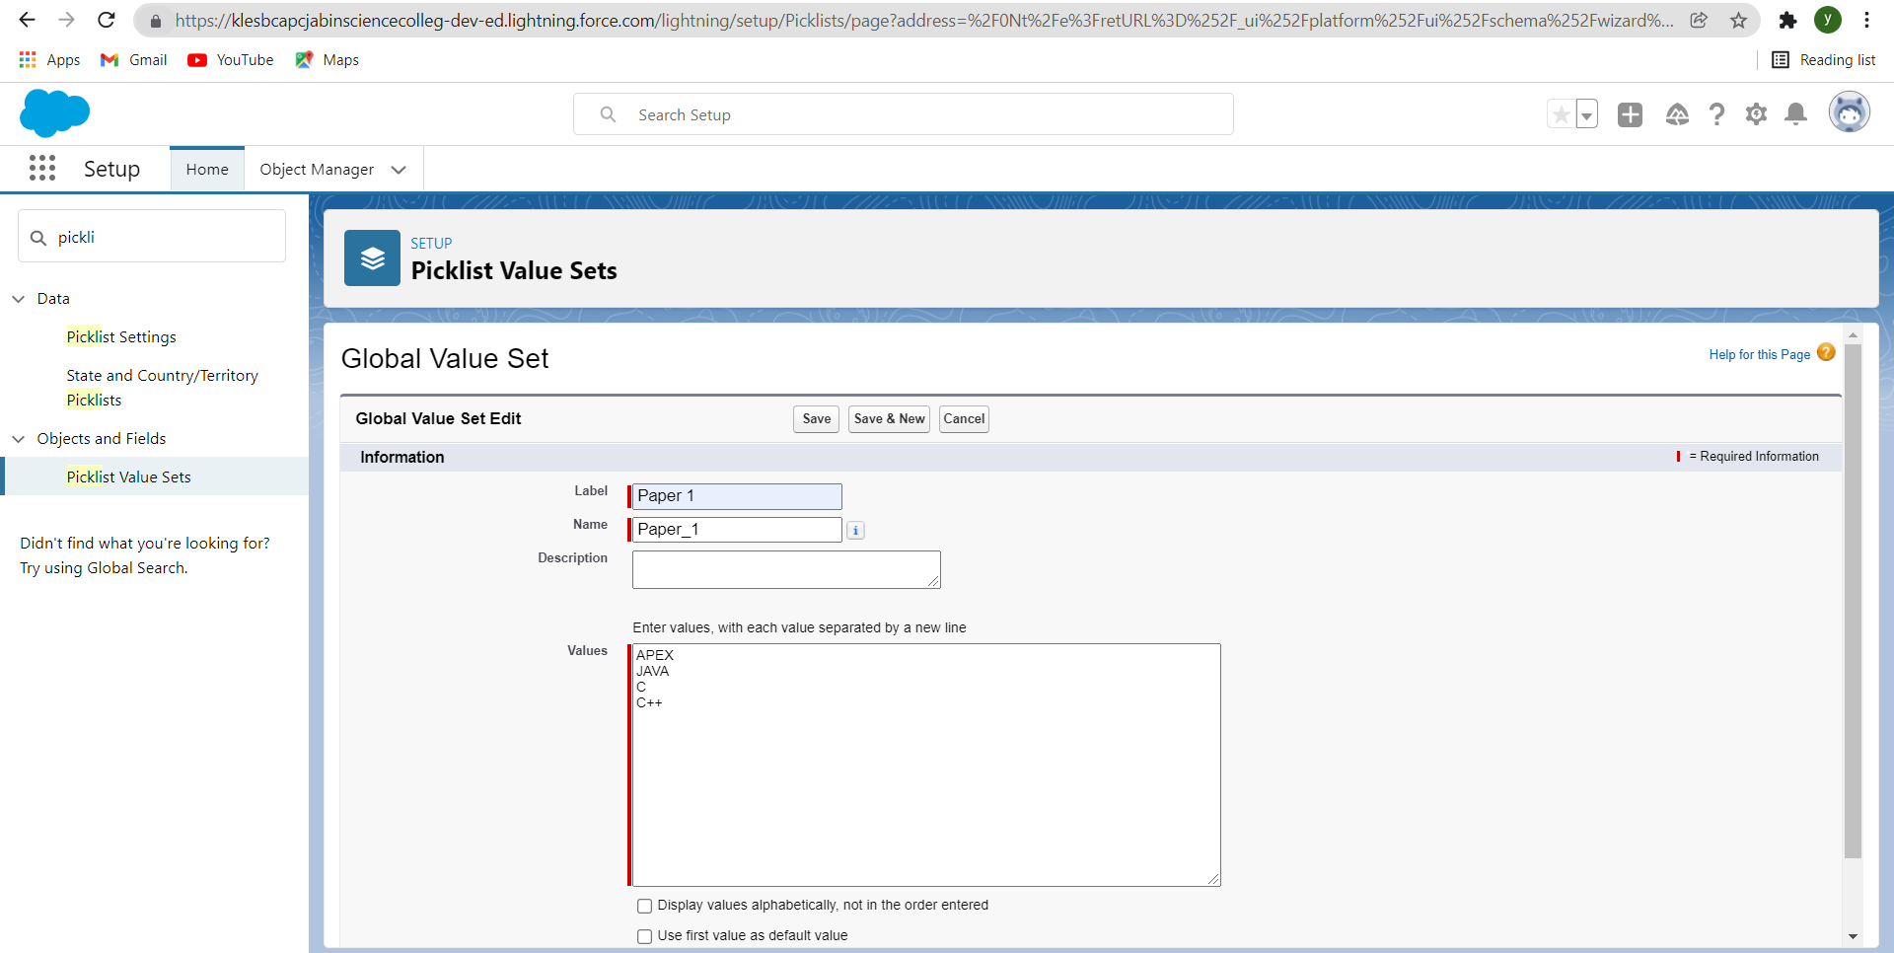

3)Paper 2

|  |  |
| --- | --- |
| Picklist Value Name | Values |
| Paper2 | MATHEMATICS  ENGLISH  STATISTICS |

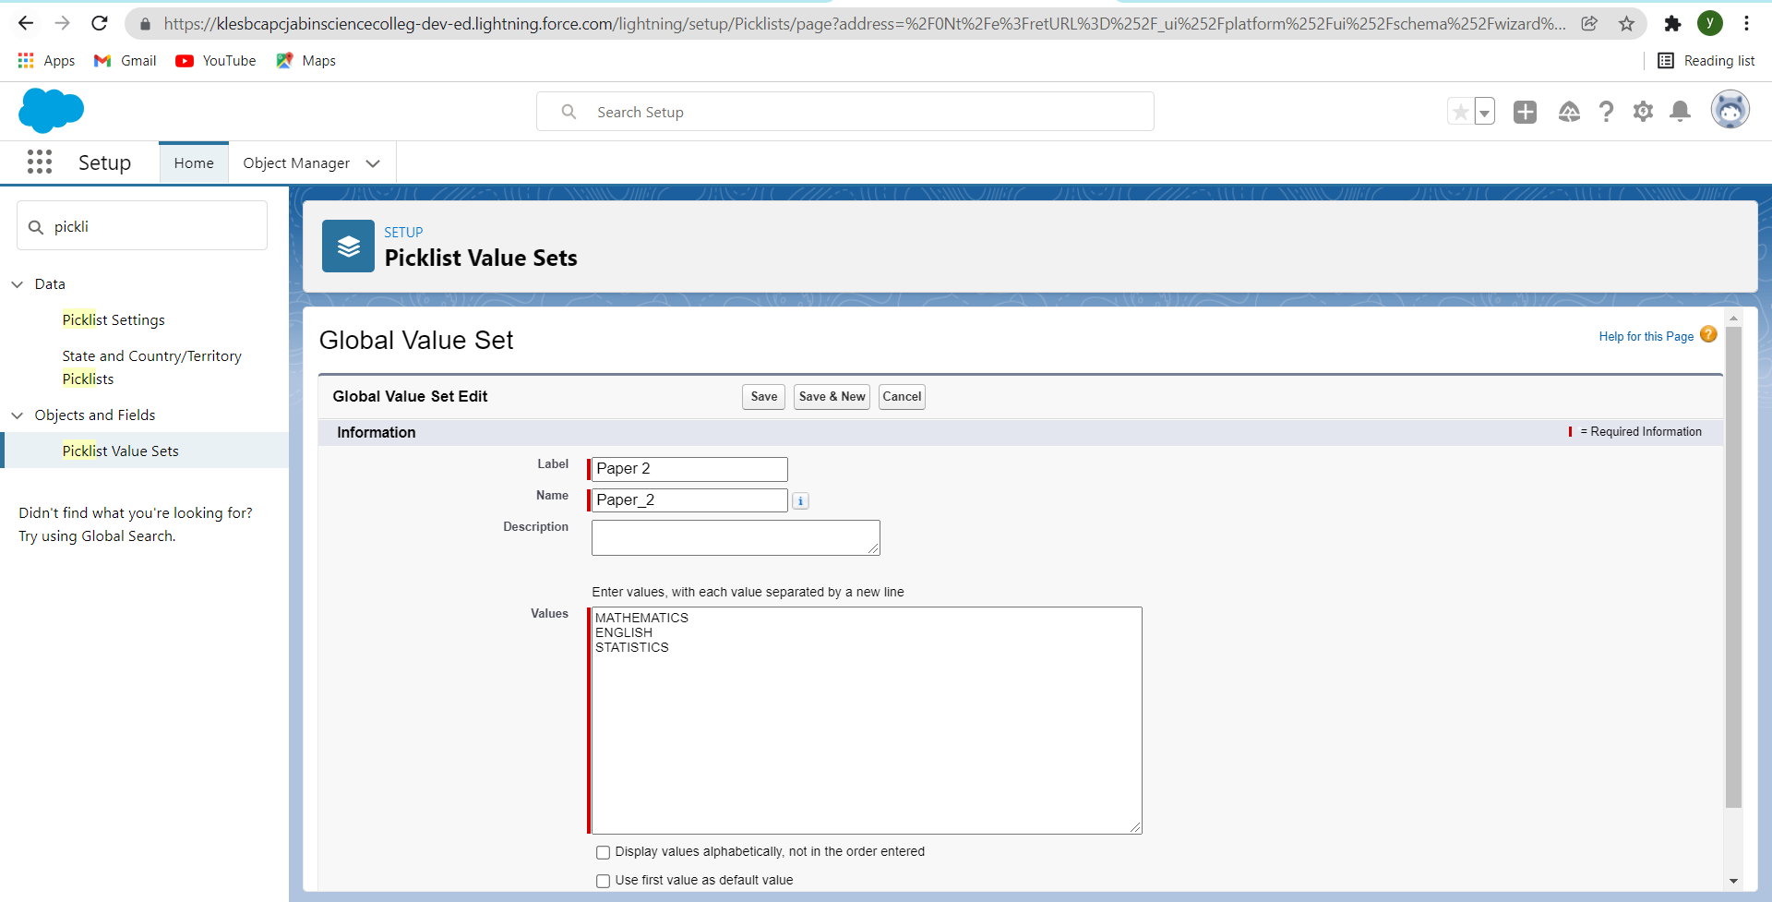

* Finaly the picklist sets looks like this:-

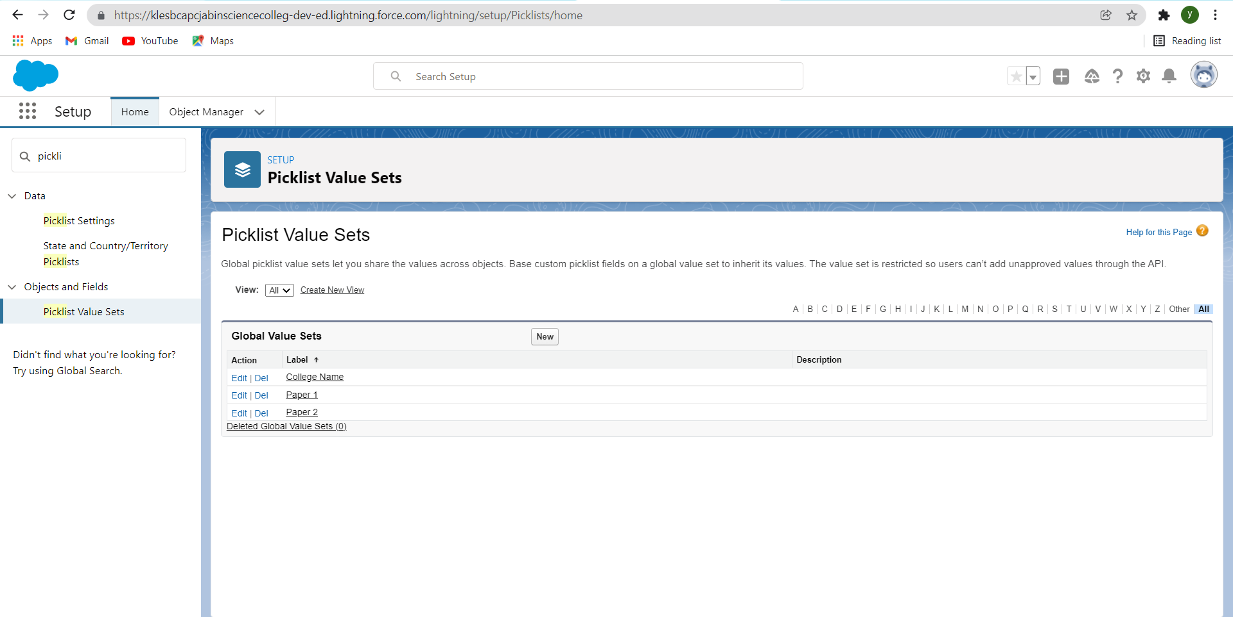

**Day 4** :

Creating Field Dependencies

Activities:

Detailed Description:

1. Create field dependency between college Name and Email, where the controlling field is college Name and dependent field is Email. Select the email ids according to the college names.

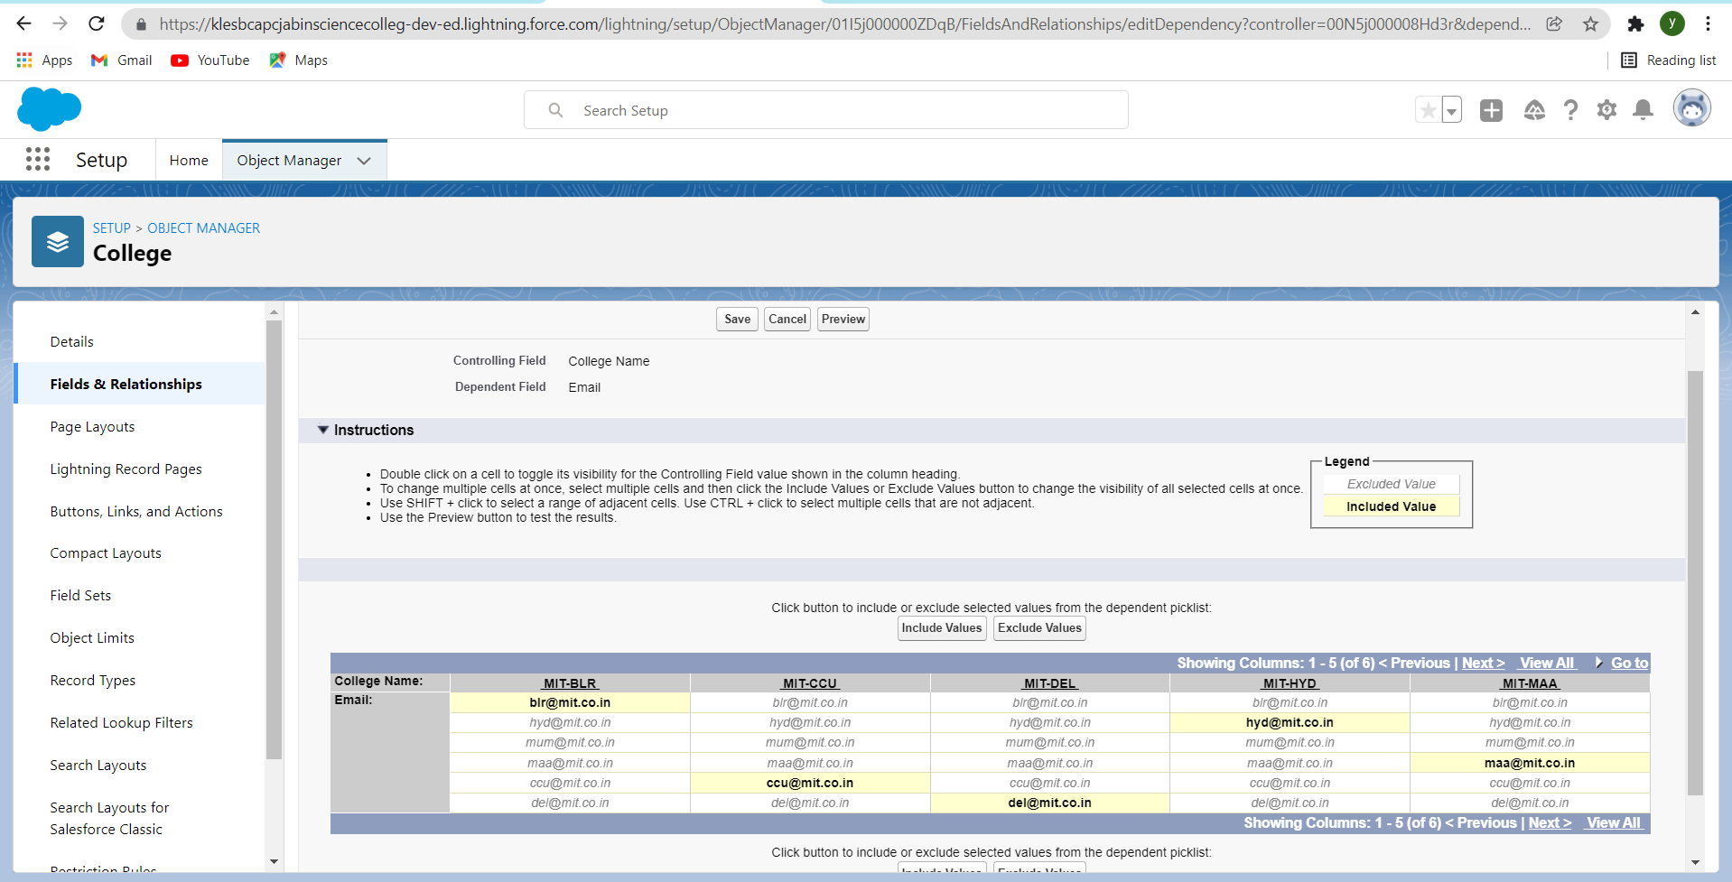

2. Create field dependency between college Name and capacity of students, where the controlling field is college Name and dependent field is Capacity of Students. Select the values according to your wish.

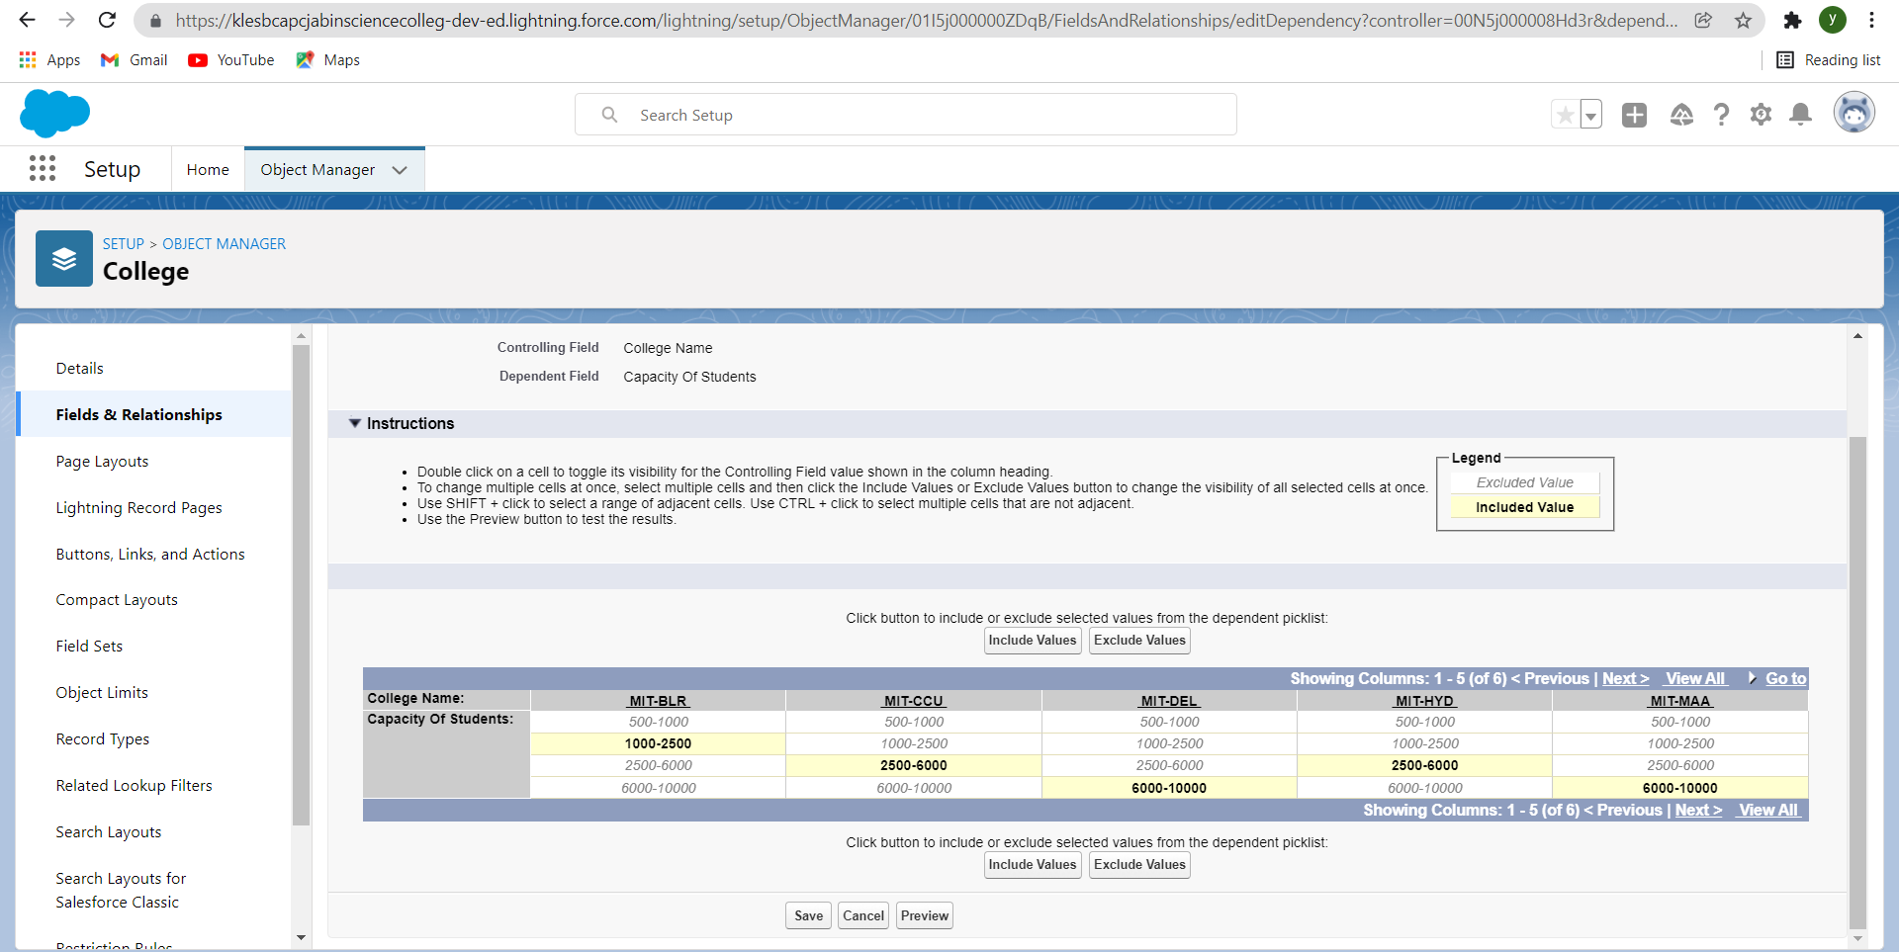

Finally the field dependencies looks like this:-

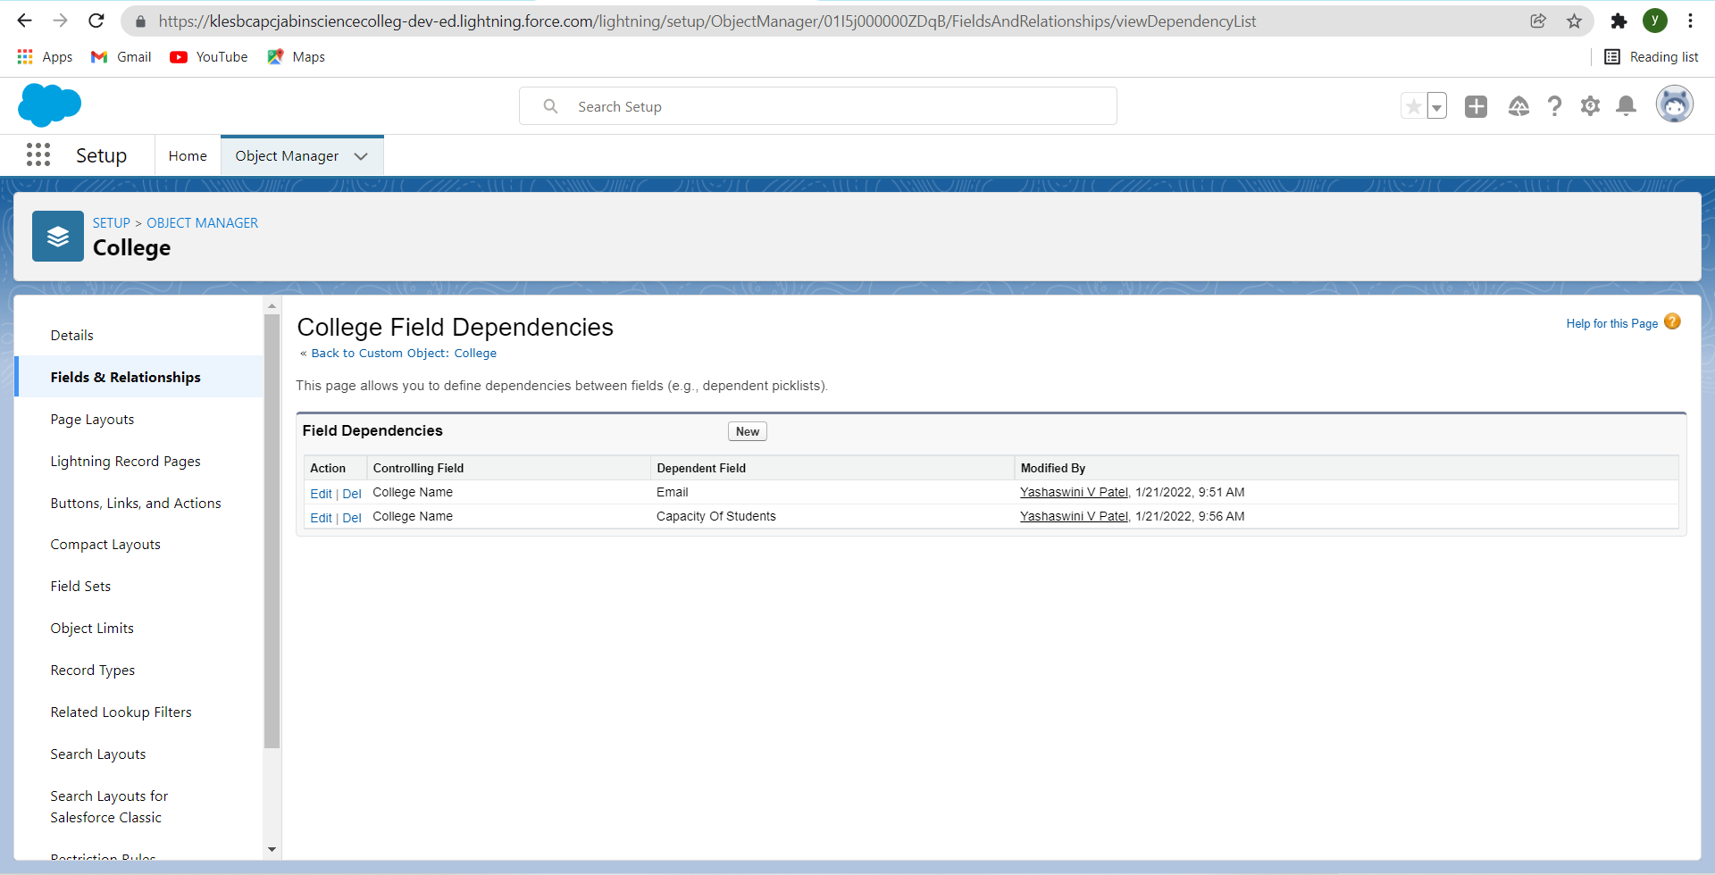

**Day 5 :**

Creating Validation Rules

Activities: Create a validation rule on the college object

Detailed Description:

1. Creating a validation rule on the college object such that the college name and record info should have the same name.

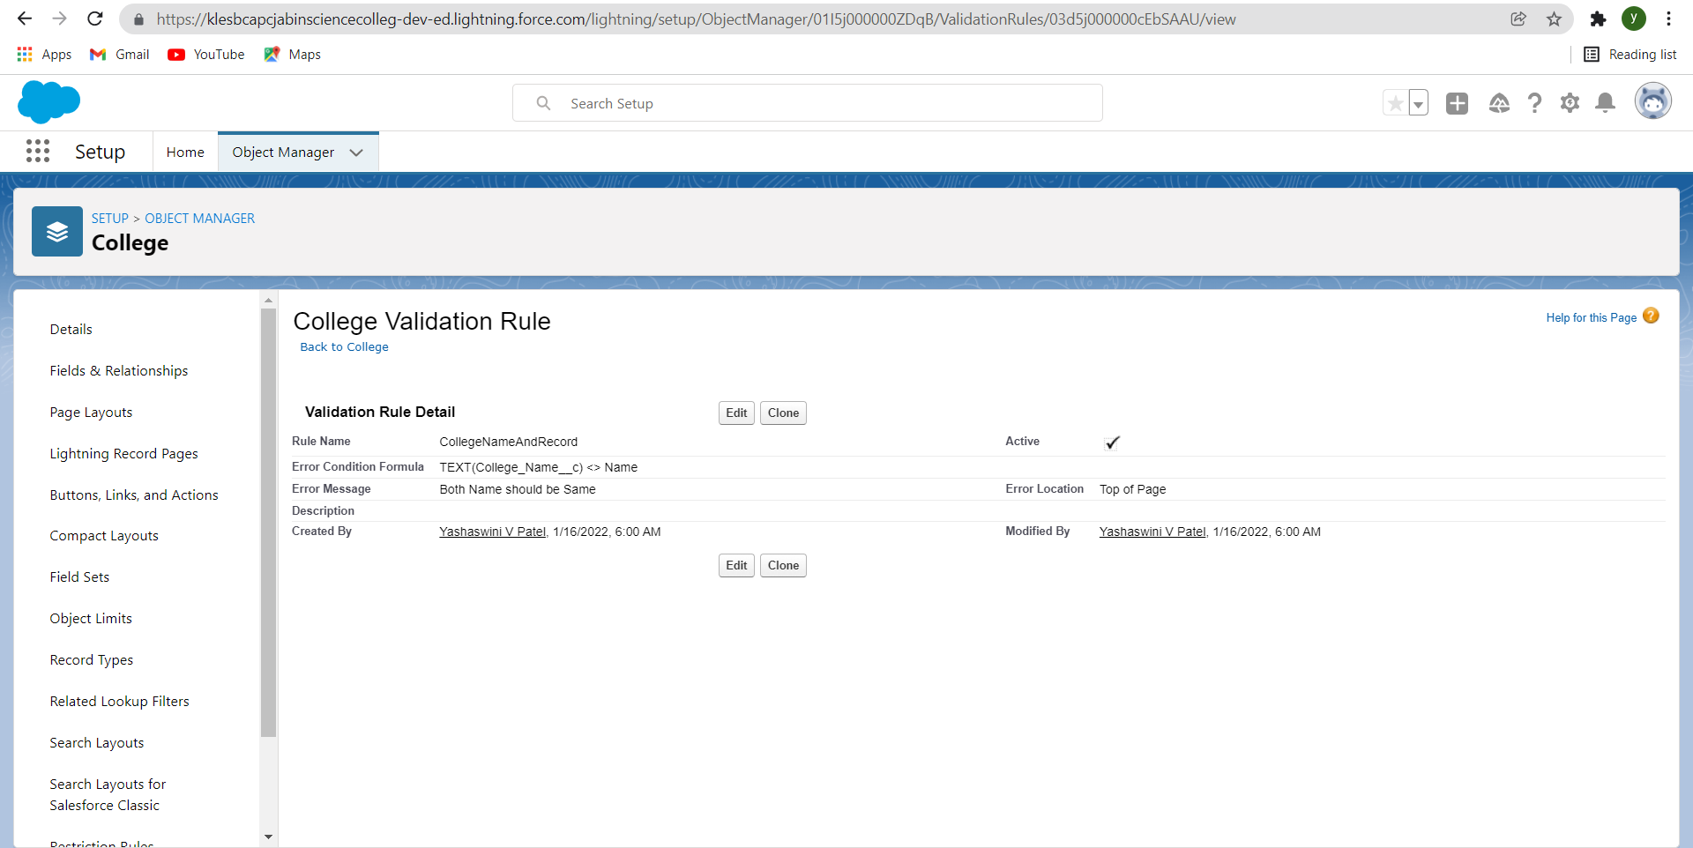

2. Create a validation rule on the application form object to stop any modification on the application form once a student record is created.

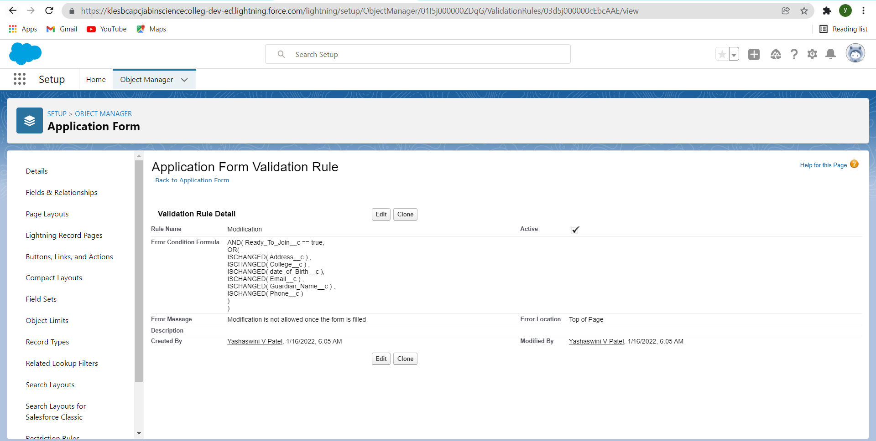

**Day 6 :**

Process Automation

Create The Student Record Using Flow

Activities:

1. Create an automation process

Detailed Description:

Create an automation process such that when the "ready to join" field is checked on the application form object we need to create the student record automatically with the information specified in the application form record.

2. Go to Setup -> select “Process Builder” from quick find. Create a Process Builder on the “Application Form” object with a condition as “When a record change”. And select “When a record is created or edited”.

1. In the diamond shape box(called nodes), select the criteria which trigger the Process builder to fire. In our example, it is “When Ready to Join field is checked.”
2. Once the node is setup, click on the adjacent box called “Immediate action”. And select create a record on the student object.

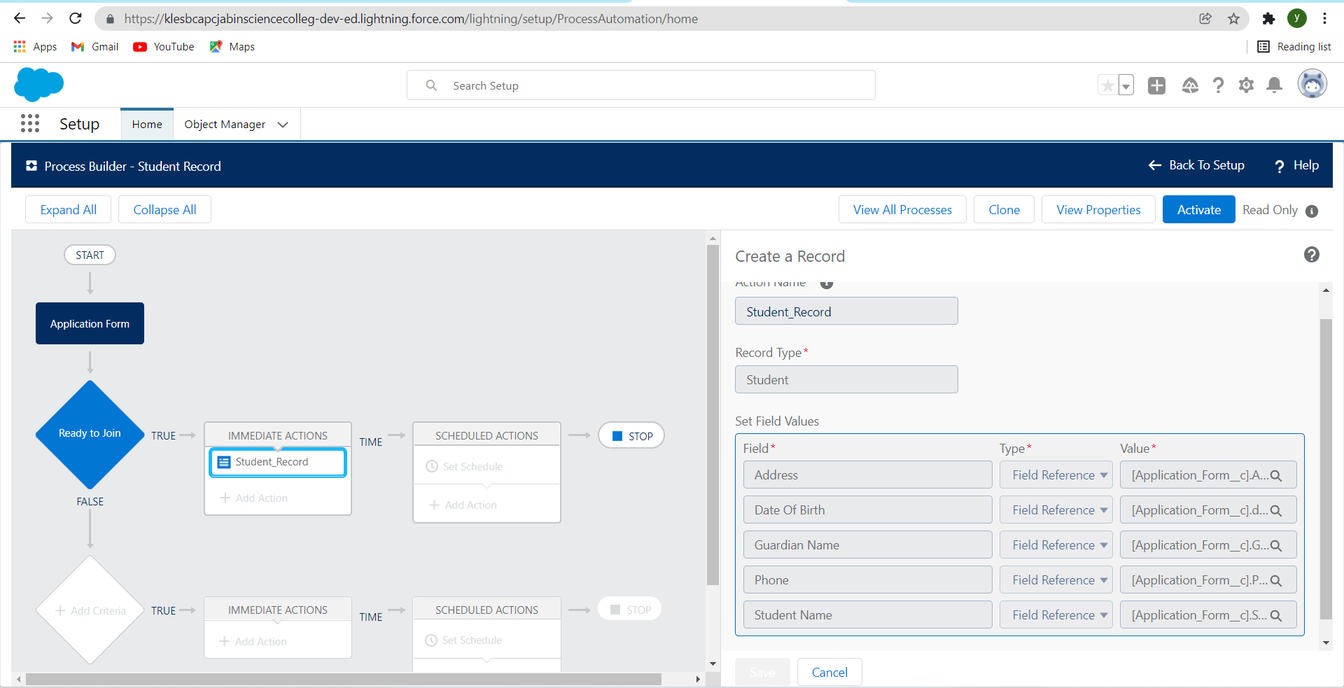

1. First deactivate the process builder which we created earlier.

2. Now search for flows and select new flow ->record triggered flow

3. For object select application form, in configure trigger select when the record is updated for entry criteria select as ready to join equals to true.

4. Now create a variable named student in the resource section.

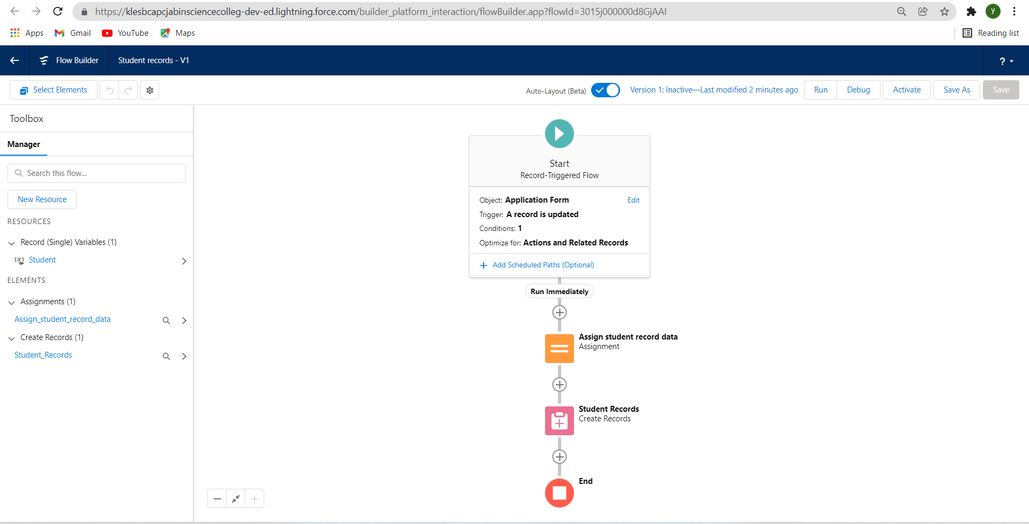

**Day 8 :** Batch Apex

Activities: Create A Batchapex For Application Form

Detailed Description: Batch Apex is used to run large jobs that would exceed normal processing limits. Using Batch Apex, you can process records asynchronously in batches (hence the name, “Batch Apex”) to stay within platform limits. If you have a lot of records to process, for example, data cleansing or archiving, Batch Apex is probably your best solution.

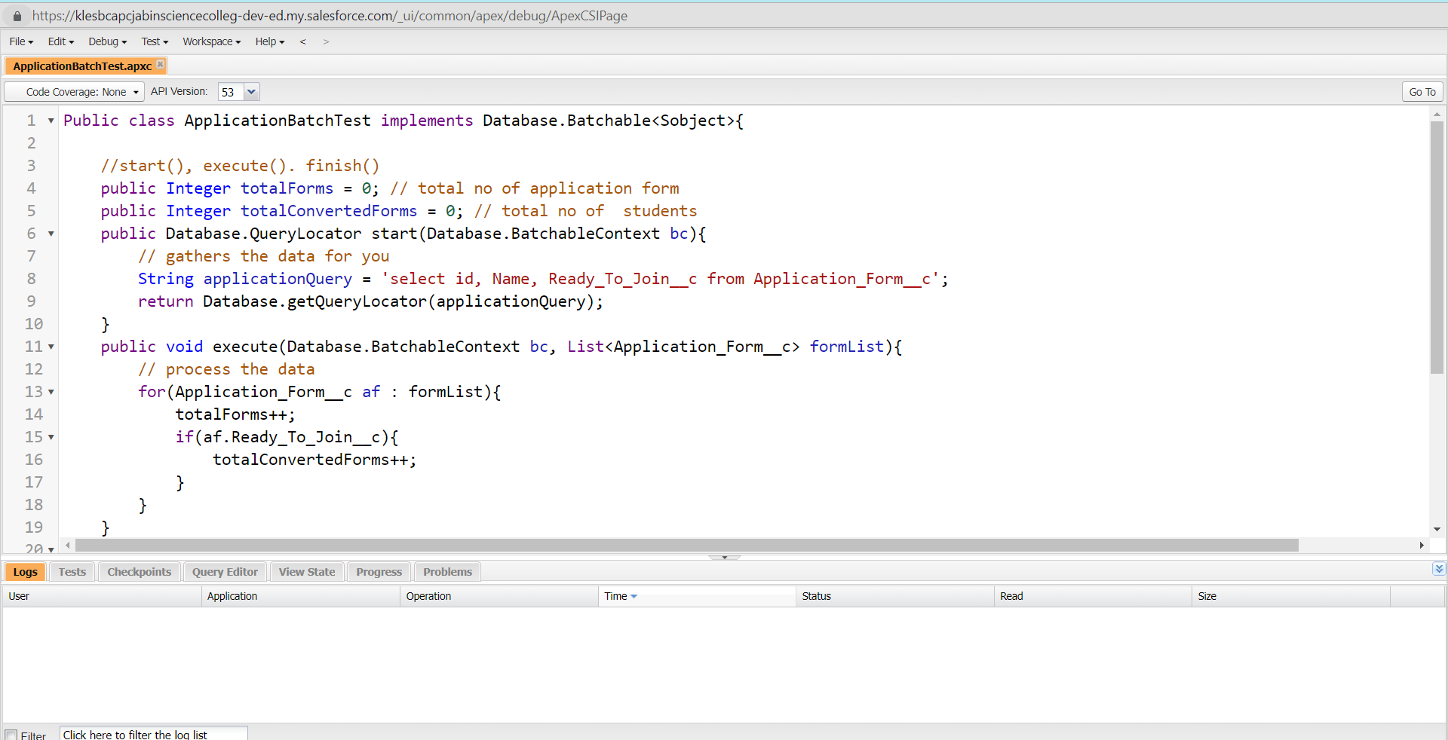

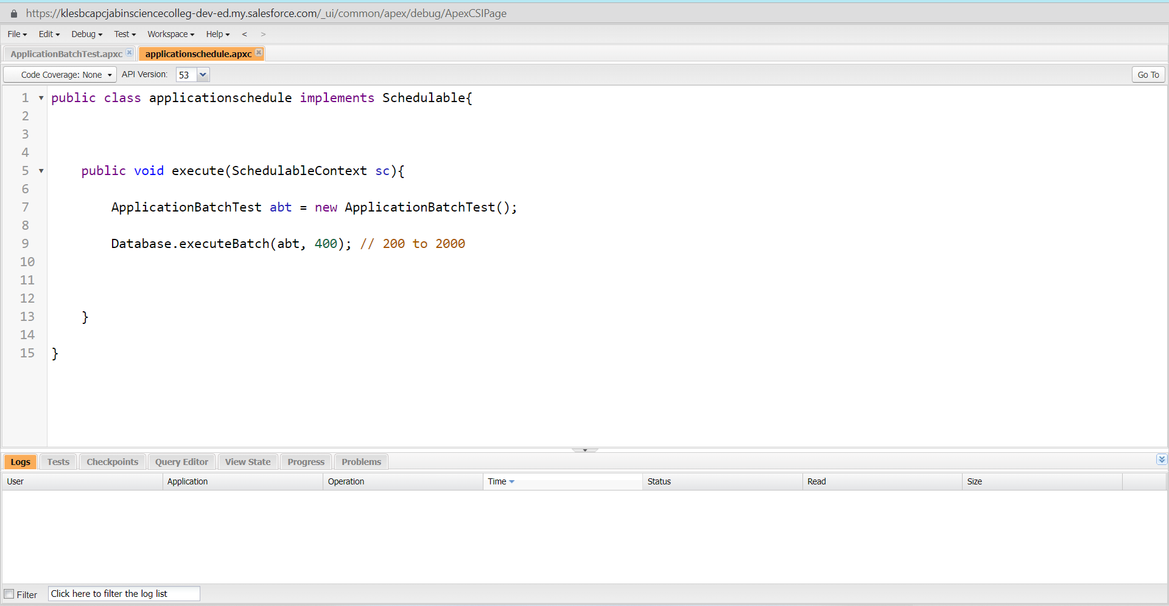

Scheduling the Apex

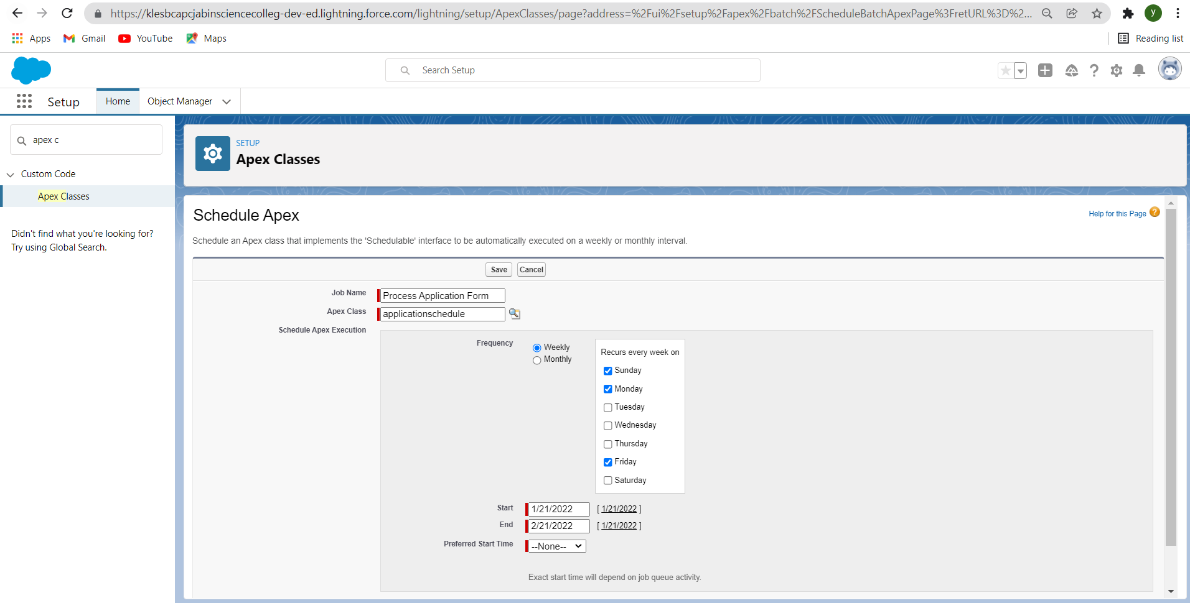

**Day 9 :**  Lightning Web Components

Activities: Create College DataTable Component( APEX CLASS)

Create College DataTable Component (HTML FILE)

Create College DataTable Component(JAVA SCRIPT FILE)

Create College DataTable Component(META FILE)

Detailed Description: Here we are going to create the college data table, for this we need to create an apex class, from which we are going to retrieve the data and Html, javascript files for UI .

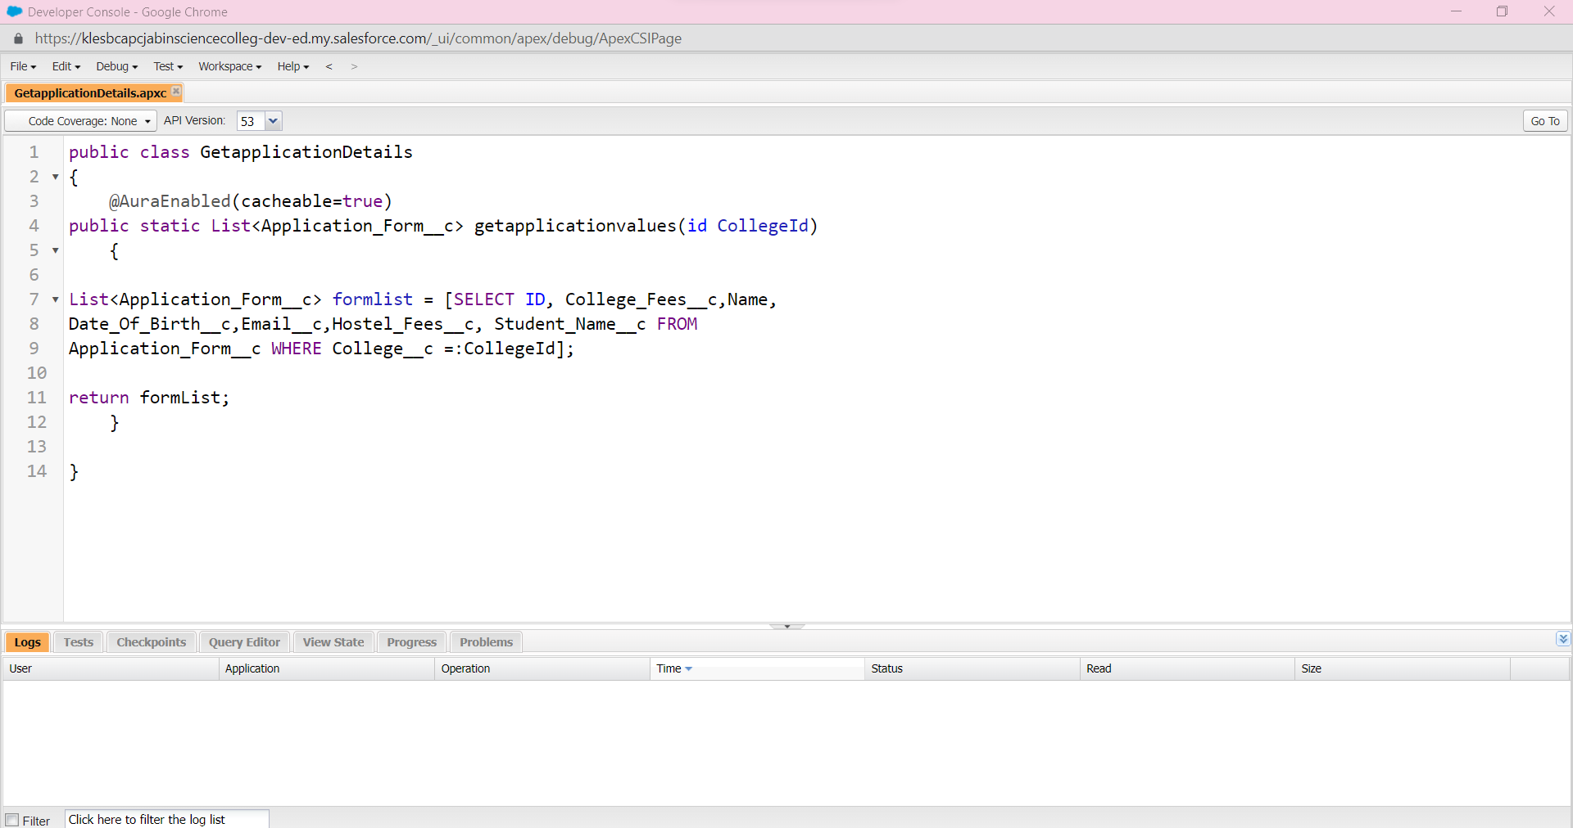

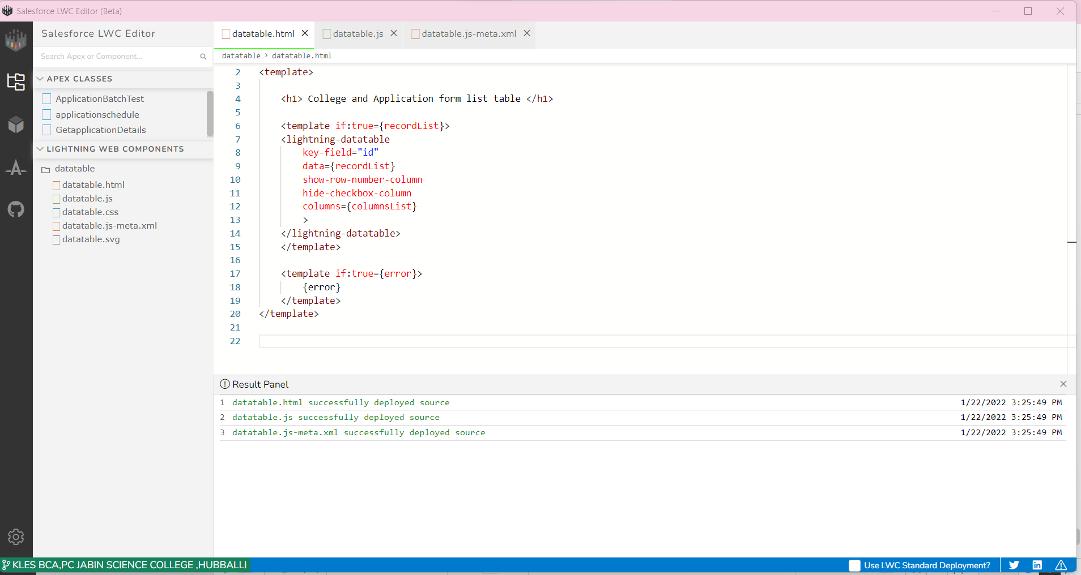

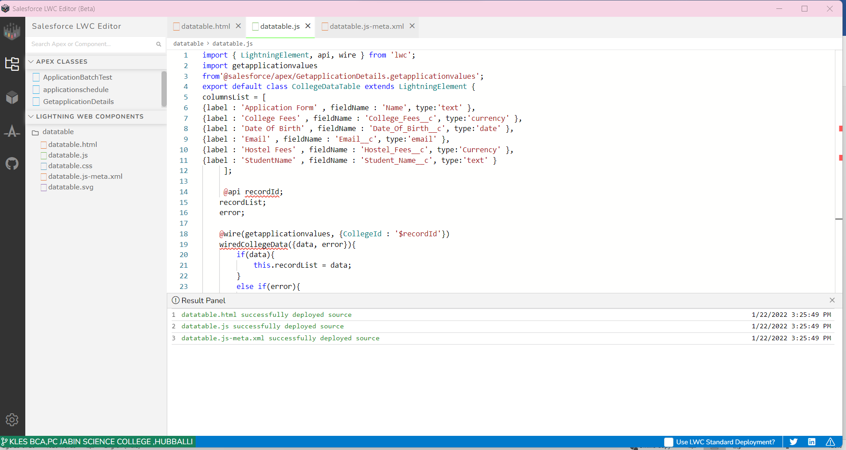

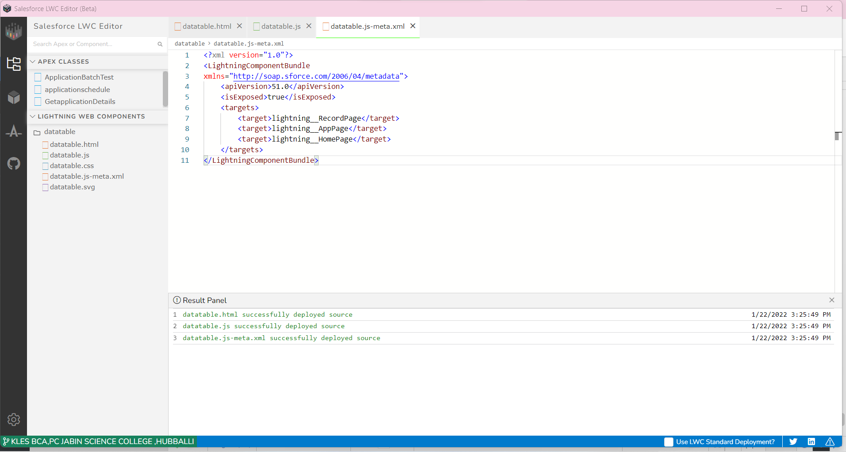

Upload the Screenshot the Activities :-

